Warwick Band Parents
8/1/16 Executive Board Meeting 6:30 & General Parent Meeting 7:30
- Welcome/Call to order by Mark Myers, president.
- Approval of last month’s minutes by Mike Himmelberger. The motion was seconded by John Cascarella at the board meeting, Rusty Dicks at the general meeting.
- Treasurer’s Report – Kyle Buckwalter
  - Note updated reports from May, June, July. The student accounts are updated in Charms up until the sale of the discount cards at this time.
  - Approval of changed budget amts due to Charms. The executive board recommends this change to the budget and a motion was made by Tracy Deimler, seconded by Karen Myers. This recommendation was brought to the general meeting and a motion to approve changed budget due to Charms was made by Aimee Taylor, seconded by Amber Kready.

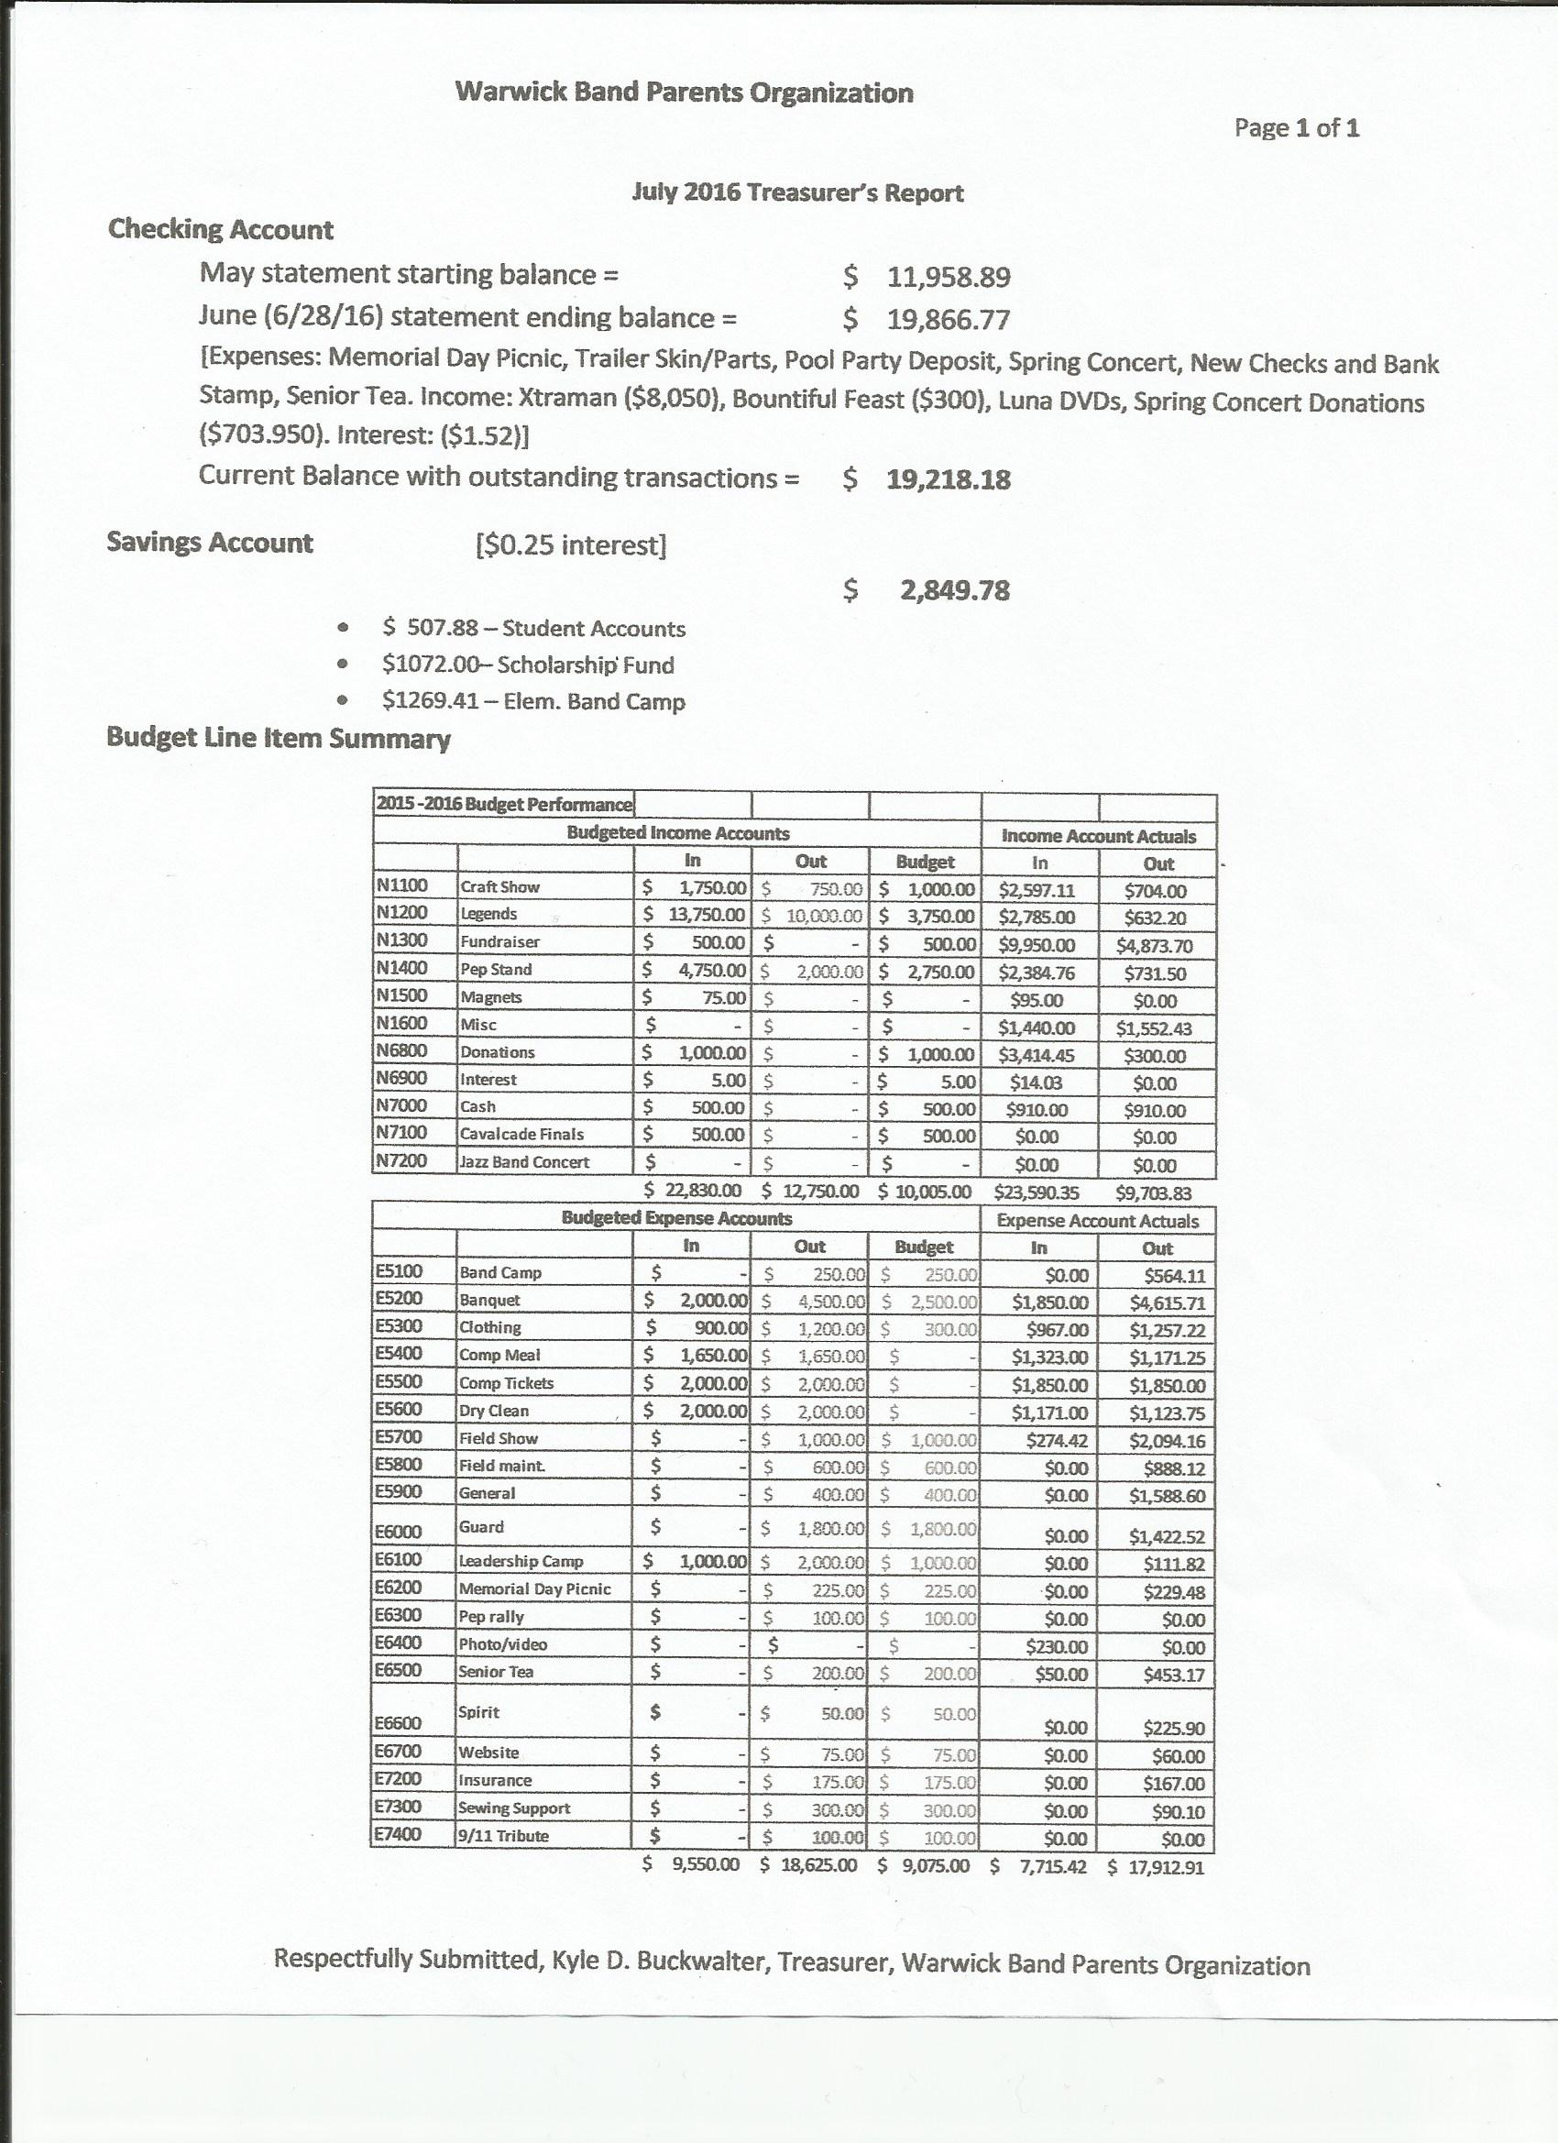

- Director’s Report
  - Wrap up items
  - Report from Mark and/or Eric, RE Meeting with HR. Mr. Wolfe is leaving to take a position at another school district. Warwick is posting the position until August 11th. Eric Rothenberger is now leader of Marching Band for the season regardless of when/if someone is hired to replace Mr. Wolfe’s position. The rest of the staff is also staying on board.
  - Band Camp Updates – Camp starts next week. This week is guard and percussion camp only.
- Uniform/Shirts/Gloves update – Mark, Eric & Jen. The new uniforms will arrive between August 15-17. We’re delaying the compression shirt purchase until the new uniforms come in and we make sure they work together which we don’t foresee to be an issue. Look to purchase the shirts online through Charms or Schuylkill Valley Sports in the near future. Please note there’s a change regarding uniform shoes (dinkles). We will not be replacing them this year so you’ll only need to replace them if your student needs a new size or they’re too worn. There will be a fitting for dinkles August 9th at noon.
- Truck Updates – We’re trying to strip the decals off the trucks now so that they can be redone.
  - Approval of new bid – Mark. The bid we have is for $3500 from Spencer at Vinyl Creations. He’s a Warwick alumni and has agreed to do this at cost for the decals and no labor charge. We have a tentative sponsor to cover the $3500 fee. Provided the proper funding is found and covered, a motion was made to recommend and approve this bid good until the September meeting by board member Michelle Himmelberger, seconded by Jen Knecht. At the general meeting this recommendation was put on the table and a motion was made by Rick Griswold and seconded by Mike Himmelberger.
  - Timeline/Condition – Mike. The design has been changed a bit so that it will cover some of the old decals that have been baked on by the sun and will not strip off all the way. We hope to have the old stripped off by the end of this week, but it’s been taking longer than expected due to the above.
- Committee Reports
  - Sewing open – Rachelle but needs help. There are at least 3 other people that agreed to help with this. Once the new uniforms come in and the students are fitted, there will be some work to do but it shouldn’t be as much as in years past.
  - Other committees – There’s work to do on the pit carts and scrims. We’ll be removing the fabric on at least 6 scrims and replacing it with French fabric. To help with the carts and removing the scrim fabric please meet this Saturday at 8 AM at the school.
  - Pool Party – Nikki – anything need to be done. 6 chaperones are needed from the band and Nikki will also be getting the same from the Warbler’s.
  - Band camp snacks – Amber – Drinks are still needed August 15-18. Please sign up on Charms or contact Amber to donate these.
- Home Show Status – There’s only 3 bands signed up to attend and we need at least 4-5 to make a profit. A decision has to be made in the next week whether to have the show or not. If not, there was discussion on other fundraising ideas or the possibility of attending a competition that week so the students are not off a total of 3 weeks.
- Old Business
  - Purple Turtle Update – The dates for this fundraiser are August 29 – September 3.
20% of all clothing and gift certificate purchases go to the band when you show the flyer or a picture of the flyer at check out.
  - Craft Show is coming up August 13th. There are still slots open to sign up and help on Charms or let Rusty know if you will be there.
  - Uniform Pillows cost is $40. Permission is needed from the school board to get rid of uniforms and anything else going forward. Delivery of pillows should be the 2nd week in September.
    - Banner
- Parent Preview is August 25th at 7 PM.
- New Business – Appreciation for Mr. Wolfe’s years at Warwick. It was decided that Kyle Buckwalter will buy a $100 gift certificate to Fox Chase Golf Club using money from the miscellaneous budget. Anyone who wishing to donate money towards the gift may do so to Kyle and he will deposit any donations back into the account. A motion to accept was made by Tracy Deimler and seconded by Lori Ruchalski.
- Adjourn - a motion was made by Mike Himmelberger and seconded by Rachelle Buckwalter.

